**Simplify your life with the Custom US Keyboard**

Note: this article is written as a promotion for my Github project at: https://github.com/frankliu197/Compose and written to be a tutorial like other articles on this blog.

**Introduction**

This keyboard is designed as an extension to the default US keyboard, adding the functionality of typing special characters such as Latin/Greek characters, mathematics and physics symbols. No keys and/or key combinations from the original US keyboard have been changed. It can only be used on Linux.

Here are the following additions:

* Type any combination of the following accents: acute, breve, caron, cedilla, circumflex, diaeresis, grave, macron, tilde

ẍ, ṕ, ṻ and even ǖ

* Type all Greek letters

υ, α, β

* Type many math symbols, more than you probably need (create a pull request if I am missing any)

≡, ∀, ≋, ≩, ⊊, ∰, ¾

* Type superscripts and subscripts

⁴, ⁺, ₀

* Type other symbols that may be useful for your life

¥, ¶, µ, ¿, °

* Circle any letter or symbol like

ⓔ

Usage and installation explanations will be explained below.

**Usage**

This keyboard features four levels of key shifting. It means that you can type four different characters per key on your keyboard. Let’s take a look at an example below:

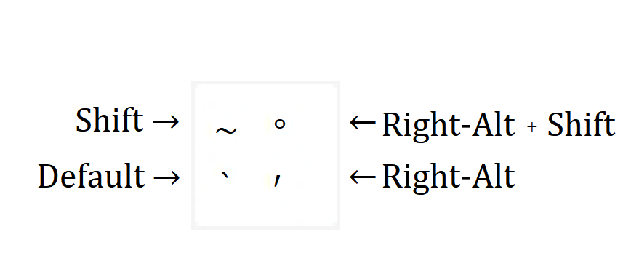

This is the custom keyboard’s implementation of the most upper-left key of your keyboard. By default, by pressing this key, you will print out the ` (grave) symbol. You can print out the ~, **°**,and′ symbols by pressing any sort of “shift” key, including the shift key, the third level shift key (which by default is the Right-Alt) and/or pressing a combination of the shift keys for the fourth level shift.

Below is a quick reference of the key mappings of the keyboard. It is not required to know where all the keys are.

You will notice that this keyboard contains almost no keys that I have specified in the introduction. Most of these keys are written though the dead keys (as shown in gray above), or the compose key, which is explained later.

Here are a few quick points about the keyboard’s layout:

* A comprehensive list of accents is found in the third and fourth level shift on the right side of the keyboard, where the punctuations are. You can use these accents with the compose key to properly other non-English Latin characters.
* The dead keys are found in the third and fourth level shift, on the right side of the keyboard.

**Dead Keys:**

Dead keys are similar to a modifier key (like shift), but they only create one type of characters:

**Dead Inverted** (Right-Alt + -)

Inverts the keys upside down

dead_inverted + A → ∀

**Dead Superscript** (Right-Alt + \)

Changes the next letter into its superscript form

dead_superscript + 1 → ¹

**Dead Subscript** (Right-Alt + |)

Changes the next letter into its superscript form

dead_subscript + 1 → ₁

**Dead Music** (Right-Alt + _)

Maps musical keys

dead_music + e → ♪ (eighth note)

**Dead Currency** (Right-Alt + +)

Maps currency symbols

dead_currency + y → ¥ (yen symbol)

dead_currency + c → ¢ (cent symbol)

**Dead Greek** (Right-Alt + =)

Maps Greek letters. There is more than one letter in Greek. It starts with the same letter (e.g. tau and theta). Some Greek keys are not mapped in a position that is favorable.

dead_greek + a → α (alpha)

dead_greek + G → Γ (capital gamma)

dead_greek + t → τ (tau)

dead_greek + j → θ (theta)

**Compose Key (default: Right-Control):**

Compose keys will combine a combination of keys graphically to form another character.

Math Symbols:

compose + = + _ + space → ≡

compose + < + _ + space → ≤

Accents:

Duplicating Symbols:

Other symbols:

On Ubuntu, compose keys also compose keys that logically work together, but this is no longer true.

compose + = + < ↛ ≤

compose + ^ + 1 ↛ ¹

The order you press the keys is very important. It must start from left to right, and top to bottom.

compose + - + + + space → ∓

compose + + + - + space → ±

compose + ¯ + ¨ + u → ṻ

compose + ¨ + ¯ + u → ǖ

As the key order of some characters is slightly ambiguous, there are multiple key combinations to make the same symbol. In these cases, as long as you don't stray too far from the rules outlined here, you should have no problem writing your symbol of desire.

compose + | + / + space → ∤

compose + / + | + space → ∤

compose + = + _ + space → ≡

compose + _ + = + space → ≡

The key order of slash is slightly different. Similar to the modifier, the slash will only be placed a slash on the next key. If you want to slash out the whole combination, you must press slash last.

compose + ~ + / + = + space → ≆

compose + ~ + = + / + space → ≇

All key combinations with the compose key must end with the space key. This is not true for the default Ubuntu configurations, but for this keyboard, it is used to prevent longer compose key sequences from overriding the shorter ones such as ≤ and ≰ (the second being just a slash more).

Finally, you may notice that there are two slashes, the normal slash ( / ) and the division slash ( ∕, Right Alt + . ). Use compose with division slash for all division related keys, and use the normal slash otherwise.

compose + 1 + division_slash + 3 + space → ⅓

Using Compose Key with Dead Keys:

Note that the dead_key only modifies the next key. Thus the dead_inverted in the combination below:

compose + dead_inverted + ? + !

will only invert the question mark, and not the exclamation mark. However, you could use

compose + dead_inverted + ? + dead_inverted + ! to invert both keys.

Always start with the compose key if you are planning to do a composition of keys. It does not matter whether your key combination contains dead keys or not.

Compose key phrases:

When the Compose Key is only used with letters, it will print out a text phrase instead. These combinations created to type phrases you type often faster.

compose + g + p + space→ git push origin master (g for git and p for push)

compose + j + p + space → System.out.println( (j for java and p for print)

These key combinations are editable in the Compose file.

Visit my tutorial here to learn how to edit your custom keyboard in more detail.

**Installation**

If you want to learn how to set up your own keyboard, click here. Otherwise, follow the instructions below to set up the keyboard with default configurations.

WARNING: If you created/edited the files: /usr/share/X11/xkb/symbols/us or ~/.XCompose, blindly following the steps below will delete all your custom configurations. You will need to tweak the steps below so it would be compatible with your current keyboard.

1. Download the keyboard source code into your computer.

```

git clone https://github.com/frankliu197/Compose

cd Compose

```

2. Move the keyboard settings files onto your computer:

```

sudo cp us /usr/share/X11/xkb/symbols/us

ln -sf .XCompose ~/.XCompose

```

3. Change directory into /usr/share/X11/xkb/rules/ and change several configuration files

```

cd /usr/share/X11/xkb/rules

```

In /usr/share/X11/xkb/rules/evdev.xml, inside the \<layout\> with the configItem us, e.g.

```xml

<layout>

<configItem>

<name>us</name>

<shortDescription>en</shortDescription>

<description>English (US)</description>

<languageList>

<iso639Id>eng</iso639Id>

</languageList>

</configItem>

<variantList>

```

add the following the the variant list:

```xml

<variant>

<configItem>

<name>custom_us</name>

<shortDescription>Custom US Keyboard</shortDescription>

<description>Custom US Keyboard</description>

</configItem>

</variant>

```

Then in evdev.lst, under

```

! variant

```

add:

```

custom_us us: English (Custom)

```

You may have to do the same thing for base.xml and base.lst. A simple shortcut would be to execute the following two commands:

```

sudo cp /usr/share/X11/xkb/rules/evdev.lst /usr/share/X11/xkb/rules/base.lst

sudo cp /usr/share/X11/xkb/rules/evdev.xml /usr/share/X11/xkb/rules/base.xml

```

4. Install uim (Universal Input Manager) on your Linux system. On Ubuntu, run:

```

sudo apt install uim

```

5. Add the following lines to your ~/.profile

```

# Use uim instead of ibus or fcitx

# Allows you to use the custom keyboard combinations

export GTK_IM_MODULE=uim

export QT_IM_MODULE=uim

```

6. Reset/restart two services (Note: You will log out):

```

setxkbmap

sudo systemctl restart lightdm

```

Depending on your OS, the second command may not work. Alternatively, you can restart your computer instead.

7. Congratulations! You are done installing! The custom-us keyboard should pop up as one of your systems available keyboards. You will need to add this keyboard layout through Settings→ Keyboards to use it.

Copy compose from here https://help.gnome.org/users/gnome-help/stable/tips-specialchars.html.en